NEW YORK ELITE ALLEYCATS FC EDWARD PLACKE
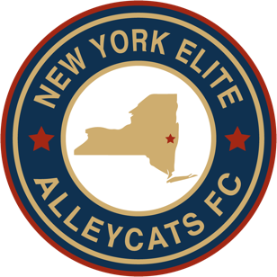
SPORTSMANSHIP SCHOLARSHIP

NYEAFC presents this scholarship in honor and recognition of Edward "Ed" Placke for his dedicated service to Capital District youth soccer. He devoted many years establishing soccer programs for area youths to play in a fun, competitive and enriching environment, with many of whom have grown into fine young adults. With his retirement from Capital District soccer, NYEAFC would like to recognize Ed Placke for his accomplishments which will continue to have an impact for years to come. In the spirit of NYEAFC soccer, the club will select two players to each receive a $250 college scholarship based on their exemplary model of true sportsmanship in the sport of soccer.

Application Instructions

- ELIGIBILITY: Applicants must be class of 2022 graduating high school seniors attending college in the fall and are active NYEAFC club members in good standing.
- Please fill in the information requested below.
- Email completed applications to Blair Downie at brdownie62@gmail.com or
mail to Blair Downie, 819 4th Ave, Troy, NY 12182
- Applications must be received by June 3, 2022

Applicant Information

Name
Address
Phone
email
Number of Years playing Club Soccer with NYEAFC

Academic Information

Name of High School
Grade Point Average
Class Rank/# in Class
Graduation date (month/year)
Academic Awards/Honors
Name of post-secondary school you plan to attend or list of those you have applied to
Intended Major

Extracurricular Activities

Please describe the extracurricular activities in which you have participated during the past four years. Indicate school year(s) (grade level) for each activity, note special awards, honors and offices held. Insert additional rows in table if necessary.

School Year | Activity | Awards, Honors, Offices Held

Community Service

Please describe the community service/volunteer work in which you have participated without pay during the past four years. Indicate school year(s) (grade level) for each activity, approximate number of hours per week, and number of weeks per year. Insert additional rows in table if necessary.

School Year | Organization | Community Service Activity | # hours per week | # weeks per year

Work Experience

Please describe your work experience during the past four years. Indicate school year(s) (grade level) for each job, approximate number of hours worked each week, and number of weeks worked each year. Insert additional rows in table if necessary.

School Year | Employer | Position | # hours per week | # weeks per year

